Assignment 14

R-7.1 Draw a simple, connected, undirected, weighted graph with 8 vertices and 16 edges, each with unique edge weights. Identify one vertex as a “start” vertex and illustrate a running of Dijkstra’s shortest path algorithm on this graph.

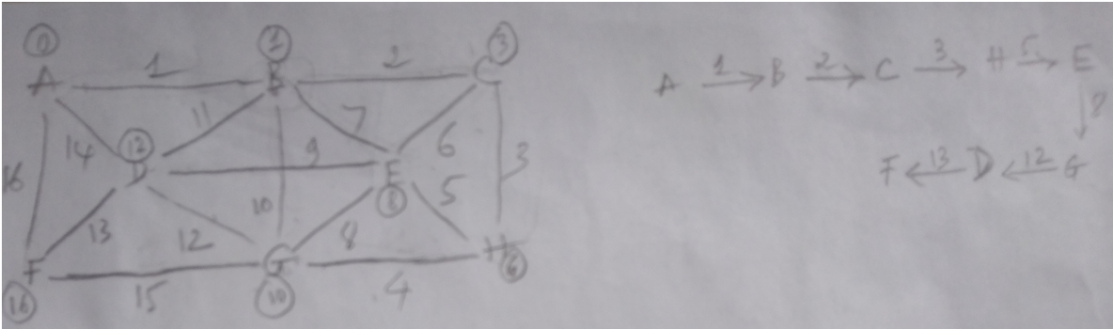

|  |  |  |  |  |  |  |  |  |
| --- | --- | --- | --- | --- | --- | --- | --- | --- |
| Dijkstra’s | A | B | C | D | E | F | G | H |
| Start | 0 | ∞ | ∞ | ∞ | ∞ | ∞ | ∞ | ∞ |
| A | x | 1 | ∞ | 14 | ∞ | 16 | ∞ | ∞ |
| B |  | x | 3 | 12 | 8 | - | 11 | - |
| C |  |  | x | - | - | - | - | 6 |
| H |  |  |  | - | - | - | 10 | x |
| E |  |  |  | - | x | - | - |  |
| G |  |  |  | - |  | - | x |  |
| D |  |  |  | x |  | - |  |  |
| F |  |  |  |  |  | x |  |  |

R-7-8 Draw a simple, connected, undirected, weighted graph with 8 vertices and 16 edges, each with unique edge weights. Illustrate the execution of Prim-Jarvik's algorithm on this graph. (Note there is only one minimum spanning tree for this graph.)

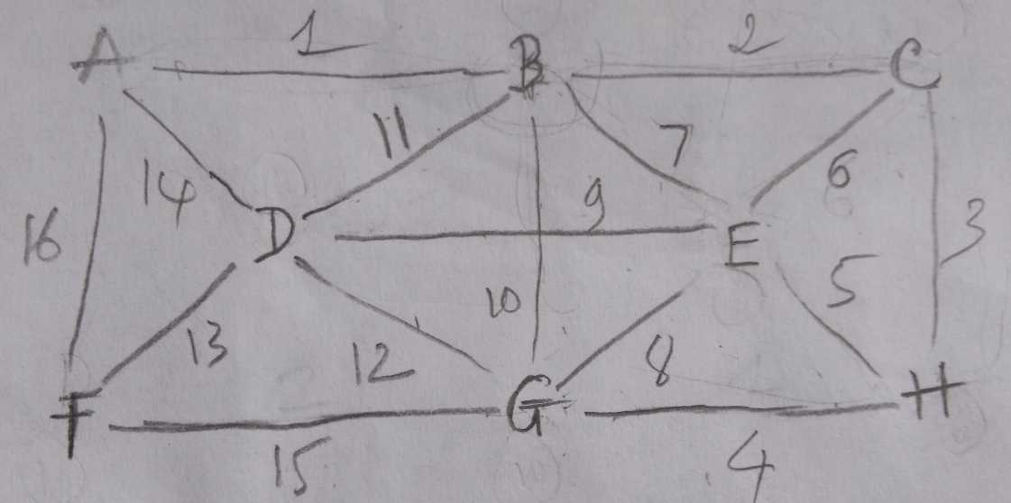

|  |  |  |  |  |  |  |  |  |
| --- | --- | --- | --- | --- | --- | --- | --- | --- |
| Prim-Jarvik's | A | B | C | D | E | F | G | H |
| A | x | 1 |  |  |  | 16 |  |  |
| B |  | x | 2 | 11 | 7 | - | 10 |  |
| C |  |  | x | - | 6 | - | - | 3 |
| H |  |  |  | - | 5 | - | 4 | x |
| G |  |  |  | - | - | 15 | x |  |
| E |  |  |  | 9 | x | - |  |  |
| D |  |  |  | x |  | 13 |  |  |
| F |  |  |  |  |  | x |  |  |

R-7-9 Repeat the previous problem for Baruvka's algorithm.

1. Using your BFS template from yesterday’s assignment, override the hook methods so it calculates the number of edges in each path from the starting vertex to the other vertices in the tree calculated by BFS (you calculated paths in yesterday’s assignment). For example, if a vertex w is 2 edges away from the starting vertex v, then 2 would be stored at w. This is similar to Dijkstra’s algorithm for calculating distance except that distance is the number of edges (as if the edge weight is 1 for ever edge). Note also that this distance is the level number that we showed in the slides. See the diagram in the notes at the end of Dijkstra’s shortest paths.

|  |
| --- |
| startVertexVisit(G, v)  setLevel(v, 0)  postDiscoveryTraversal(G, v, e, w)  l <- v.getLevel()  setLevel(w, l) |

2. Consider the following potential MST algorithms based on the generic MST algorithm. Which, if any, successfully computes a MST? Hint: to show that an algorithm does not compute an MST, all you need to do is find a counterexample. If it does, you need to argue why based on the cycle property and/or the partition property.

a. G has n vertices and n-1 edges, now 1 edge is removed, this doesn’t ensure G is not still MST, another thing the minimum total edge weight should re-calculate by Dijkstra’s or Prim’s algorithm.

b. G has n vertices and n-1 edges, now 1 edge is added, this doesn’t ensure G is not still MST. Besides, the minimum total edge weight must be calculated with new edge weights.

c.

C-5.1 A native Australian named Anatjari wishes to cross a desert carrying only a single water bottle. He has a map that marks all the watering holes along the way. Assuming he can walk k miles on one bottle of water, design an efficient algorithm for determining where Anatjari should refill his bottle in order to make as few stops possible. Argue why your algorithm is correct.

Do this with two different assumptions:

1. Assume the watering holes are all located along the same road/path

2. Assume the watering holes are spread over the whole desert, i.e., there is no road.

R-7.7 Repeat the previous problem R-7.8 for Kruskal's algorithm.